
Company
Logotype

Cone Beam Computed Tomography- Report



Porur Dental X-rays & CBCT

Patient Name : Mrs. Benisha Jeyolin | Date of Report : 04.06.2024
Age/ Gender : 27 years/ Male | Region of Interest : CBCT Sectional Maxilla
Referring doctor: Dr. Selva Ganesh | Indication : Assessment of 24
Clinical Notes: Nil
PATIENT INFORMATION

CBCT- Sectional Maxilla provided
CBCT – IMAGE DETAILS

RADIOGRAPHIC INTERPRETATION

- In relation to 24, hyperdense crown structure with hyperdense restorative material involving the crown and extending into the buccal and palatal root canal upto the apical third is evident.
- In relation to the periapical aspect of 24, presence of mild area of hypodensity, measuring 3.19 x 3.88 x 3.96 mm in dimension with diffuse margins is evident.
- The alveolar bone in relation to the maxillary alveolar ridge is present with normal trabecular pattern.
- The mesio-proximal region of 25 is present with an area of hypodensity involving the enamel, dentin and in proximity to the pulp.

RADIOGRAPHIC IMPRESSION

- Root canal treated tooth: 24 with periapical pathology.
- Dental caries: 25.

Kindly correlate with clinical findings


IMAGES FOR REFERENCE

RECONSTRUCTED PANORAMIC VIEW

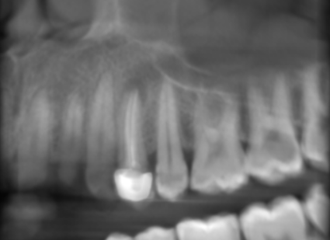

3-DIMENSIONAL VIEW
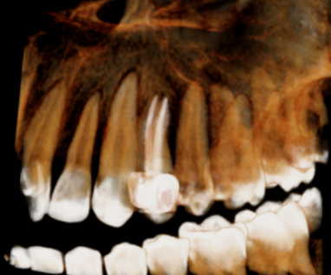

CROSS SECTIONAL VIEW

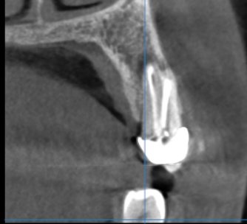

MULTIPLANAR VIEW

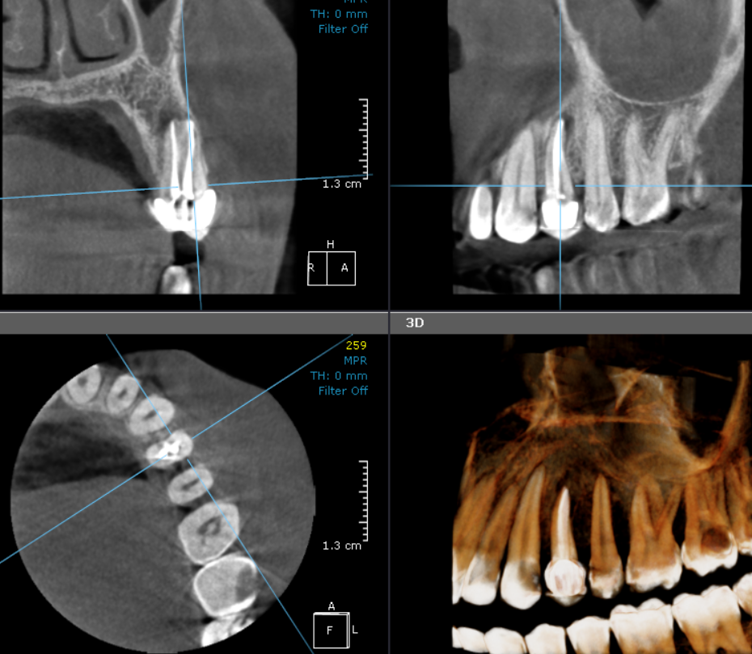

**** End of report ****

